**ABOUT TOOLS:**

It allows our chat model to access internet to give the answers to user asked questions. Tool is allows to access the external environment with various functionality, in RAG we give some built in data with chat prompt, that is called knowledge base, but here with tool we augment or expand our knowledge base to more.

That is called Agentic AI.

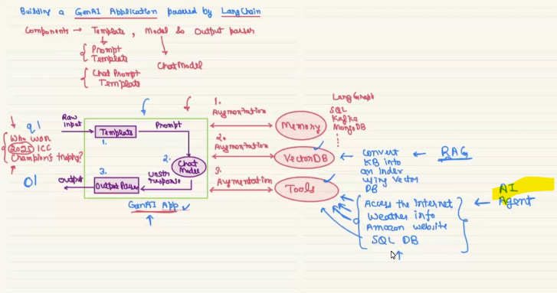

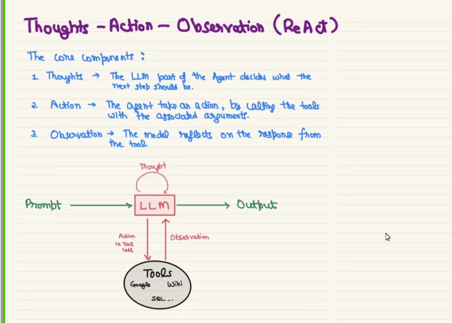

**CODE IMPLEMENTATION**

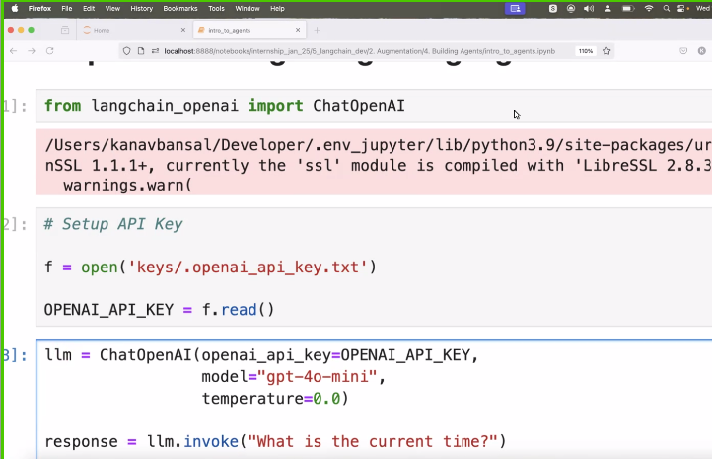

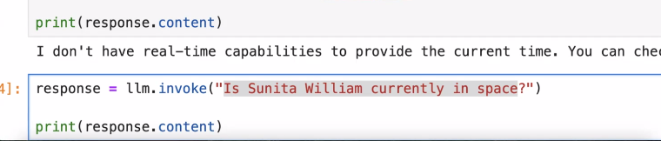

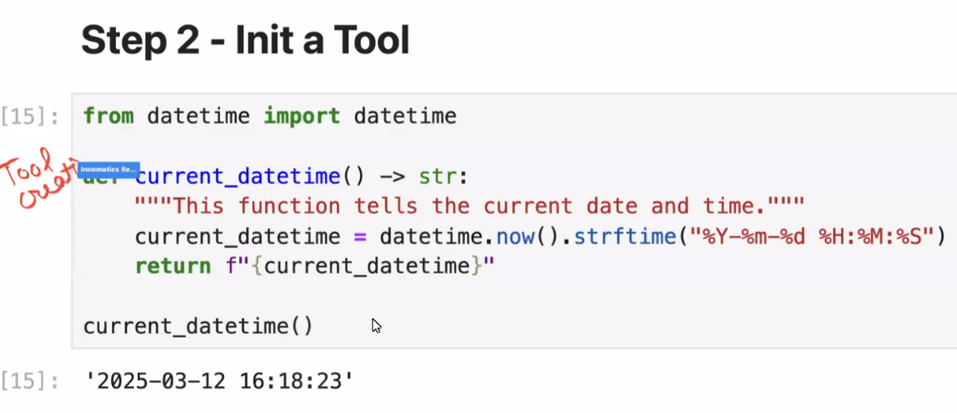

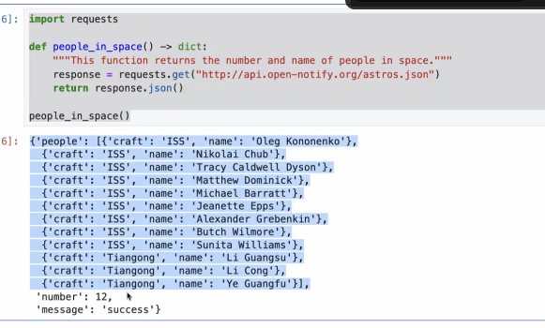

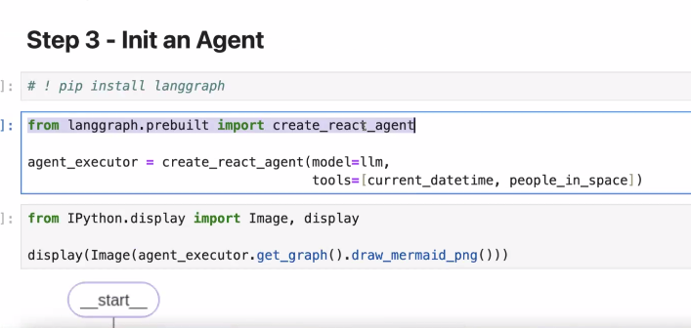

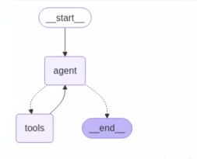

**Agent_executor.invoke(user_propmt)**

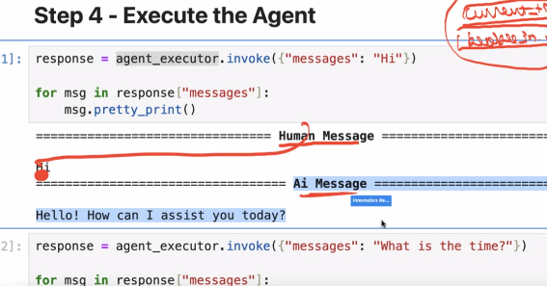

**OTHER IMPLEMENTATION LIBRARIES**

